**Failure Analysis in Financial Systems**  
Sean Daniel Parrell  
University of Florida

**Table of Contents**

1. Introduction ...............................................................................................3
2. Types of Failures in Financial Systems .................................................3  
   2.1 Market Volatility ...................................................................................3  
   2.2 Platform Failures ..................................................................................4
3. Testing Types and Methods ....................................................................5  
   3.1 Non-Destructive Testing ......................................................................5  
   3.2 Forensic Methods and Audits .............................................................6  
   3.3 Relevant Industry Standards ...............................................................6
4. Case Study: The 2021 Gamestop Short Squeeze .................................7  
   4.1 Case Description ...................................................................................7  
   4.2 Case Investigation ..............................................................................8
5. Recommendations ..................................................................................9
6. References ...............................................................................................11

**1. Introduction**

The Gamestop short squeeze of 2021 was a landmark event that captured global attention, demonstrating significant failures in both market structure and platform operations [1]. Financial systems, which play a critical role in global economies, face immense stress during periods of high volatility, and this stress often exposes weak points in system resilience, regulatory oversight, and platform management. The Gamestop event was one example where market volatility, combined with platform instability, led to widespread financial disruption, revealing both the vulnerabilities of hedge funds and the inadequacies of retail trading platforms like Robinhood.

This paper will analyze the causes of the 2021 Gamestop short squeeze, focusing on the types of failures in the financial system that contributed to this event. The analysis will include an examination of relevant testing methods, industry standards, and case-specific failures that impacted both institutional investors and retail traders. Recommendations will be made to mitigate future occurrences of similar failures. The lessons from this event will serve as an essential case study on how financial systems must evolve to accommodate modern trading platforms and the increasing role of retail investors.

**2. Types of Failures in Financial Systems**

**2.1 Market Volatility**

Market volatility is a central element of financial markets, where asset prices fluctuate rapidly in response to external factors like economic indicators, political events, and market speculation. However, the Gamestop short squeeze really showed a type of volatility that was driven primarily by social media coordination and retail investors acting all at once. Hedge funds had taken large short positions, betting that Gamestop’s stock price would fall further. In contrast, retail investors, many of them were organized on the Reddit forum WallStreetBets, began purchasing Gamestop shares in large volumes. This collective buying created a feedback loop, driving up the stock price and triggering a short squeeze [2].

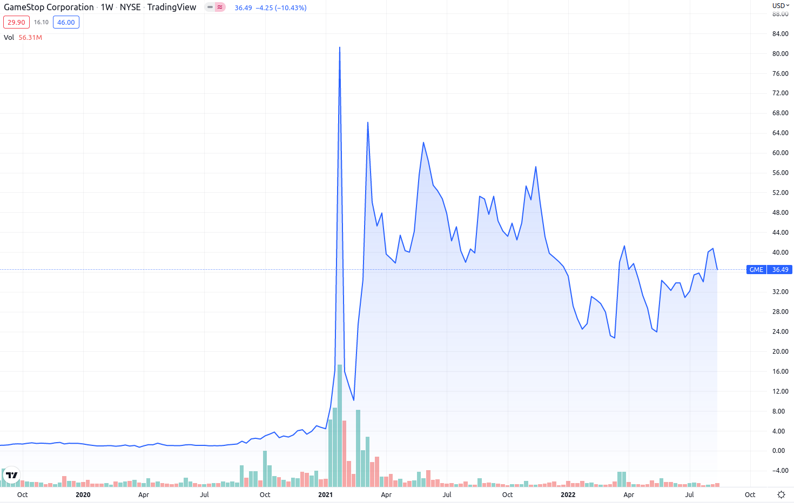

Figure 1: A chart that shows the rapid price fluctuations of the Gamestop stock price during the beginning part of the year 2021 and then corresponding stock prices are seen to the right of the screen in a chart-like format [9].

Hedge funds found themselves in an increasingly untenable position as they had to buy back Gamestop shares at much higher prices to cover their short positions. The stock price soared from less than $20 to over $400 in just a few weeks, causing billions of dollars in losses for institutional investors [3]. This dramatic price movement illustrated the susceptibility of financial systems to coordinated actions by retail investors and revealed the risks associated with over-leveraging short positions.

The failure to manage such volatility comes from the over-reliance of hedge funds on short positions without adequately accounting for the potential impact of retail investors. Hedge funds typically assume that individual retail traders will have little impact on overall market movements. However, the Gamestop event showed that organized retail trading can pose significant risks, particularly when social media platforms allow for rapid dissemination of information and coordination. The volatility exposed the lack of contingency planning by hedge funds, which underestimated the potential for a short squeeze of this magnitude [4].

**2.2 Platform Failures**

While the market volatility during the Gamestop event was one aspect of the failure, an equally significant issue was the inability of trading platforms like Robinhood to handle the surge in trading volume. Robinhood, which had built its brand on offering easy access to stock trading for retail investors, found itself at the center of the controversy when it halted trading in Gamestop shares at the height of the short squeeze. The platform’s decision to suspend trading was due to liquidity concerns; Robinhood needed to meet increased collateral requirements from its clearinghouses due to the high volatility of Gamestop’s stock [5].

The halt in trading sparked outrage among retail investors, many of whom believed that Robinhood was protecting hedge funds at the expense of individual traders. The platform’s communication with its users was also problematic. Robinhood did not adequately explain the reasons for the trading halt, leading to widespread speculation and accusations of market manipulation. This failure in transparency further decreased trust in the platform.

Robinhood’s struggles highlighted a broader issue within retail trading platforms: the difficulty of maintaining liquidity and managing risk during periods of extreme market activity. The platform was caught between the need to protect its financial stability and the expectations of its users. The inability to strike a balance between these competing demands exposed systemic issues in Robinhood’s operational management and risk assessment strategies [6]. Furthermore, the platform’s reliance on payment for order flow, a business model that requires minimal margins, left it vulnerable to liquidity shortages when faced with unprecedented trading volumes.

**3. Testing Types and Methods**

**3.1 Non-Destructive Testing in Financial Systems**

In financial markets, non-destructive testing methods are used to assess the resilience of institutions and platforms without causing actual disruptions. Stress testing is one of the most common non-destructive methods used to simulate extreme market conditions and assess how well financial systems can withstand stress. Stress tests evaluate a platform’s ability to manage liquidity, handle large trading volumes, and meet regulatory requirements during periods of market volatility [6].

Robinhood’s failure during the Gamestop short squeeze suggests that its internal stress testing procedures were inadequate. Had the platform conducted more rigorous stress tests, it might have identified vulnerabilities in its liquidity management and taken preemptive measures to avoid halting trading. Simulating a scenario like the short squeeze would have revealed the strain that clearinghouse collateral demands could place on the platform’s liquidity, allowing Robinhood to develop a more robust risk management strategy [1].

Hedge funds involved in shorting Gamestop stock could also have benefited from conducting stress tests on their investment strategies. Shorting large volumes of stock carries inherent risks, particularly when those stocks become the target of coordinated buying efforts. By stress testing their short positions, hedge funds could have better anticipated the potential for a short squeeze and taken steps to mitigate their exposure to extreme price fluctuations [1].

**3.2 Forensic Methods and Audits**

Forensic analysis plays a crucial role in understanding the failures that occur in financial systems, especially after significant market events like the Gamestop short squeeze. In the wake of the event, both the SEC and FINRA launched forensic audits to investigate the actions of hedge funds, retail investors, and trading platforms. These audits were designed to determine whether any illegal activity had taken place, such as market manipulation or breaches of trading regulations [7].

Forensic audits are essential for reconstructing the sequence of events leading up to a market failure. They involve analyzing trading records, transaction logs, and communication between market participants to identify any irregularities or violations of industry standards. In the case of the Gamestop short squeeze, the audits revealed that Robinhood’s decision to halt trading was driven by the clearinghouses’ demand for additional collateral, which Robinhood was unable to meet without suspending trades [8].

Although the forensic investigations found no evidence of illegal market manipulation by either hedge funds or retail traders, they did expose significant issues in Robinhood’s liquidity management and risk assessment practices. The audits also highlighted the systemic risks posed by the growing influence of retail investors, particularly those who can organize and coordinate trading activity through social media platforms [7].

**3.3 Relevant Industry Standards**

Industry standards and regulations play a critical role in maintaining the stability of financial markets and protecting investors. Several key regulations were relevant to the Gamestop short squeeze, particularly those governing short selling and margin trading. One of the most important standards is the SEC’s Regulation SHO, which regulates short selling in U.S. markets. Regulation SHO requires short sellers to locate shares before selling them, a measure designed to prevent "naked short selling," a practice where traders sell shares they do not own [8].

In the Gamestop event, the scale of short positions held by hedge funds raised questions about whether Regulation SHO was adequately enforced. Although no evidence of naked short selling was found, the event demonstrated that large, concentrated short positions could create systemic risks, especially when retail investors coordinate buying efforts. Regulation SHO, while effective in preventing abusive short selling practices, may need to be revised to account for the evolving dynamics of modern financial markets [7].

Another key regulatory framework is the Dodd-Frank Act, enacted in response to the 2008 financial crisis to reduce systemic risk in the financial system. Dodd-Frank includes provisions requiring financial institutions to conduct regular stress tests and maintain sufficient liquidity to withstand periods of market volatility. Robinhood’s liquidity struggles during the Gamestop short squeeze suggest that the platform may not have fully adhered to these provisions or that the enforcement of Dodd-Frank’s requirements for retail trading platforms needs to be strengthened [5].

**4. Case Study: The 2021 Gamestop Short Squeeze**

**4.1 Case Description**

The Gamestop short squeeze in January 2021 was a big moment in modern financial history. Gamestop, a video game retailer struggling to adapt to the digital economy, became the center of a market frenzy when hedge funds heavily shorted its stock, betting that the company’s value would continue to decline. Meanwhile, retail investors on Reddit’s WallStreetBets forum noticed that Gamestop’s stock was significantly shorted and decided to exploit the situation by purchasing large amounts of the stock, initiating a short squeeze [3].

As the price of Gamestop shares skyrocketed, reaching over $400 per share at its peak, hedge funds that had taken short positions were forced to buy back shares at inflated prices, resulting in billions of dollars in losses. Retail investors, many of whom viewed their actions as a form of rebellion against institutional investors, celebrated their temporary victory. However, the event also exposed significant weaknesses in the financial system, particularly in the operations of retail trading platforms like Robinhood and the regulatory framework governing short selling [4].

Figure 2: A chart that shows the daily price of Gamestop stock price from the beginning of January 2021 to mid-February 2021 and then corresponding stock price as seen on the left-hand side of the picture [10].

The volatility created by the short squeeze disrupted financial markets and raised concerns about the role of retail investors in driving market movements. Hedge funds, which had placed large, leveraged bets against Gamestop, found themselves in a precarious position as retail investors continued to drive up the stock price. The event showed the power of social media platforms in organizing retail investors and the potential for these investors to influence market outcomes in ways that had previously been considered unlikely [5].

**4.2 Case Investigation**

In the aftermath of the Gamestop short squeeze, regulators launched investigations into the actions of hedge funds, retail investors, and trading platforms to determine whether any illegal activity had occurred. The SEC and FINRA conducted forensic audits of trading records and communication logs to assess whether market manipulation or other violations of trading regulations had taken place [7].

The forensic audits revealed that Robinhood’s decision to halt trading in Gamestop shares was primarily driven by liquidity concerns. The platform faced increased collateral requirements from its clearinghouses due to the high volatility of Gamestop’s stock, and it was unable to meet these requirements without suspending trading. Although Robinhood’s actions were legal, the audits exposed weaknesses in the platform’s liquidity management and raised questions about whether the platform had adequately prepared for such an extreme market event [8].

The investigation also examined the behavior of hedge funds that had shorted Gamestop stock. While no illegal activity was uncovered, the event revealed the risks associated with large, concentrated short positions and the potential for retail investors to disrupt institutional trading strategies. Hedge funds were criticized for underestimating the power of retail traders and for failing to account for the possibility of a short squeeze of this magnitude [4].

The findings of these investigations underscored the need for greater regulatory oversight of both retail trading platforms and hedge funds. The Gamestop short squeeze highlighted the growing influence of retail investors and the systemic risks they can pose when acting in large numbers. It also emphasized the need for better communication between platforms like Robinhood and their users during periods of market stress [7].

**5. Recommendations**

The 2021 Gamestop short squeeze offers several critical lessons for improving the resilience of financial systems and protecting both institutional and retail investors from similar market disruptions in the future.

One key recommendation is to **implement stricter margin requirements** during periods of extreme market volatility. Trading platforms like Robinhood must ensure that they have sufficient liquidity to meet clearinghouse demands, particularly during times of high trading volume. By imposing higher margin requirements on both institutional and retail investors, platforms can reduce the risk of liquidity shortages and avoid the need for trading halts [5].

Another important recommendation is the **enhancement of trading platform infrastructure**. Robinhood’s inability to process the surge in trading volume during the Gamestop short squeeze highlighted the need for more robust systems capable of handling large numbers of trades without compromising financial stability. Platforms should invest in technology that allows for real-time monitoring of liquidity and trading activity, ensuring that they can respond to sudden market movements without disrupting trading [6].

Regulatory reforms are also necessary to address the growing influence of retail investors in financial markets. The SEC should consider revisiting Regulation SHO to ensure that large, concentrated short positions do not create systemic risks. Additionally, regulators should explore new rules that address the potential for social media platforms to amplify retail trading activity, particularly in cases where retail investors coordinate large-scale buying efforts that can destabilize markets [8].

Furthermore, clearer communication protocols must be established to make sure that trading platforms maintain transparency with their users during periods of market stress. Robinhood’s lack of clear communication regarding its decision to halt trading damaged trust between the platform and its users. By implementing transparent communication strategies, platforms can mitigate the negative impact of trading halts and help users understand the reasons behind significant decisions [6].

Finally, trading platforms and hedge funds alike should **incorporate more rigorous stress testing** into their risk management strategies. Regular stress tests that simulate extreme market conditions, such as those seen during the Gamestop short squeeze, would allow financial institutions to identify vulnerabilities in liquidity management and develop contingency plans. Stress tests should assess platform stability, margin requirements, and the potential impact of retail investor activity, ensuring that both institutional and retail investors are protected from systemic failures [1].

**6. References**

[1] U.S. Securities and Exchange Commission, "Staff Report on Equity and Options Market Structure Conditions in Early 2021," SEC, Washington, D.C., Oct. 2021. [Online]. Available: <https://www.sec.gov/files/staff-report-equity-options-market-struction-conditions-early-2021.pdf> [Accessed: 09-Oct-2024].  
[2] M. Phillips, "4 Things to Know about the Gamestop Insanity," The New York Times, Jan. 2021. [Online]. Available: <https://www.nytimes.com/2021/01/28/business/gamestop-stock-market.html> [Accessed: 10-Oct-2024].  
[3] D. D'Souza, "Short Sellers Lose $5.05 Billion in Bet Against GameStop," Investopedia, Jan. 2021. [Online]. Available: <https://www.investopedia.com/short-sellers-lose-usd5-05-billion-in-bet-against-gamestop-5097616> [Accessed: 11-Oct-2024].  
[4] U.S. House Committee on Financial Services, "Game Stopped? Who Wins and Loses When Short Sellers, Social Media, and Retail Investors Collide," U.S. House of Representatives, May 2021. [Online]. Available: <https://financialservices.house.gov/calendar/eventsingle.aspx?EventID=407974> [Accessed: 10-Oct-2024].

[5] FINRA, "Statement to the Financial Services Committee, U.S. House of Representatives," FINRA, 2021. [Online]. Available: <https://www.finra.org/media-center/speeches-testimony/statement-financial-services-committee-us-house-representatives> [Accessed: 12-Oct-2024].  
[6] K. Duffy, "Robinhood's CEO says the trading app limited buying of GameStop stock 'to protect the firm and protect our customers'," Business Insider, Jan. 2021. [Online]. Available: <https://www.businessinsider.com/robinhood-ceo-limited-buying-gamestop-protect-firm-customers-2021-1> [Accessed: 11-Oct-2024].

[7] U.S. Securities and Exchange Commission, "Staff Report on Equity and Options Market Structure Conditions in Early 2021," SEC, Washington, D.C., 2021. [Online]. Available: <https://www.sec.gov/files/staff-report-equity-options-market-struction-conditions-early-2021.pdf>. [Accessed: 12-Oct-2024].

[8] U.S. Securities and Exchange Commission, "Regulation SHO: SEC Overview," SEC, Washington, D.C., 2020. [Online]. Available: <https://www.sec.gov/rules/final/34-50103.pdf>

[Accessed: 09-Oct-2024].  
[9] J. Lesinskis, "The Gamestop Short Squeeze (Part 3)," Lesinskis.com, 2021. [Online]. Available: <https://www.lesinskis.com/gamestop-short-squeeze-part-3.html> [Accessed: 14-Oct-2024].

[10] "GameStop Stock Chart 2021," Wikimedia Commons, 2021. [Online]. Available: <https://commons.wikimedia.org/wiki/File:GameStop_stock_chart_2021_novolume.png> [Accessed: 14-Oct-2024].